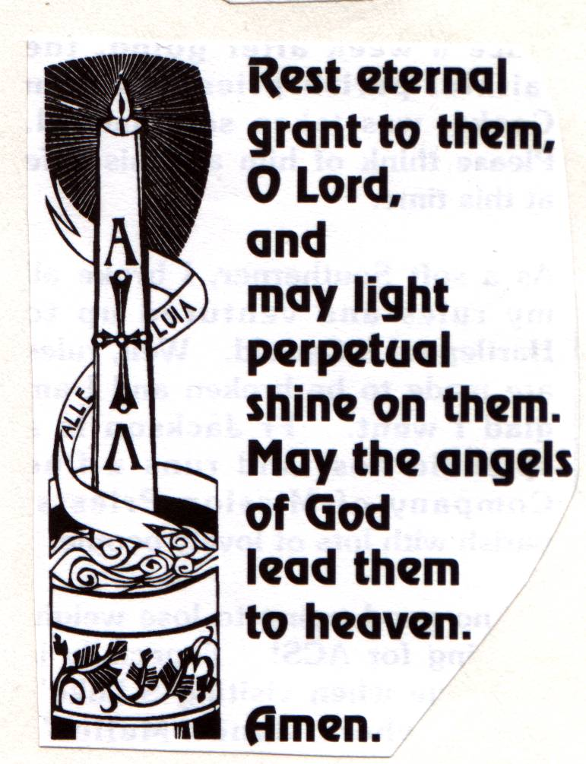

## THE GATHERING

Priest: God so loved the world that he gave his only Son, so that everyone who believes in him may not perish but may have eternal life.

We meet in the name of Jesus Christ, who died and was raised to the glory of God the Father. Grace and mercy be with you

All: and also with you.

*The priest introduces the service*

Priest: Let us pray:

Almighty God, you judge us with infinite mercy and justice and love everything you have made. In your mercy turn the darkness of death into the dawn of new life, and the sorrow of parting into the joy of heaven; through our Saviour, Jesus Christ. **Amen**

**Introit Hymn:**

In our day of thanksgiving one psalm let us offer

for the saints who before us have found their reward;

when the shadow of death fell upon them, we sorrowed,

but now we rejoice that they rest in the Lord.

In the morning of life, and at noon, and at even,

he called them away from our worship below;

but not till his love at the font and the altar,

had girt them with grace for the way they should go.

These stones that have echoed their praises are holy,

and dear is the ground where their feet have once trod;

yet here they confessed they were strangers and pilgrims,

and still they were seeking the city of God.

Sing praise, then, for all who here sought and here found him,

whose journey is ended, whose perils are past;

they believed in the light; and its glory is round them,

where the clouds of earth's sorrow are lifted at last.

#### Prayers of Penitence

Priest: As children of a loving heavenly Father, let us ask his forgiveness, for he is gentle and full of compassion.

(After a period of silent reflection)

All: Most merciful God, Father of our Lord Jesus Christ, we confess that we have sinned in thought, word and deed. We have not loved you with our whole heart. We have not loved our neighbours as ourselves. In your mercy forgive what we have been, help us to amend what we are, and direct what we shall be; that we may do justly, love mercy, and walk humbly with you, our God. Amen

Priest: Almighty God, who forgives all who truly repent, have mercy upon you, pardon and deliver you from all your sins, confirm and strengthen you in all goodness, and keep you in life eternal; through Jesus Christ our Lord. **Amen.**

**Collect:**

Merciful Father, hear our prayers and comfort us; renew our trust in your Son, whom you raised from the dead; strengthen our faith that Joan and all who have died in the love of Christ will share in his resurrection; who lives and reigns with you, in the unity of the Holy Spirit, one God, now and for ever. **Amen**

## THE LITURGY OF THE WORD

Please sit for

**A reading from the Revelation of St John the Divine** *(Revelation 21. 1-6)*

read by Mr Ian Richards

At the end of the reading

Reader: This is the word of the Lord

All: Thanks be to God

**Gradual hymn:** *(please stand)*

The Lord's my Shepherd, I'll not want;

he makes me down to lie -

in pastures green; he leadeth me -

the quiet waters by.

My soul he doth restore again,

and me to walk doth make -

within the paths of righteousness,

e'en for his own name's sake.

Yea, though I walk through death's dark vale,

yet will I fear no ill;

for thou art with me, and thy rod -

and staff me comfort still.

My table thou hast furnished

in presence of my foes;

my head thou dost with oil anoint,

and my cup overflows.

Goodness and mercy all my life

shall surely follow me;

and in God's house, for evermore

my dwelling place shall be.

#### THE GOSPEL

Priest: Alleluia, alleluia. God so loved the world that he gave his only Son.

All: Alleluia.

Hear the Gospel of our Lord Jesus Christ according to John *(Jn 14. 1-6)*

All: Glory to you, O Lord

At the end of the reading

Priest: This is the Gospel of the Lord

All: Praise to you, O Christ

#### The Address

#### The Prayers

Priest: Let us pray

Leader: God of mercy, Lord of life, you have made us in your image to reflect your truth and light: we give you thanks for Joan, for the grace and mercy she received from you, for all that was good in her life and for the memories we treasure today. Especially we thank you for Joan’s example of faith, courage and love; for all that she has done to build up the life of this church, for her courage in the face of illness, and for her dedication to, and love for, her family. We thank you for the many ways in which he has enriched our lives, and those of others, too.

Leader: Lord in your mercy

All: hear our prayer.

Leader: Heavenly Father, you promised eternal life to those who believe. Remember for good this your daughter Joanas we also remember her. Hear all our prayers for those who have died including Tom and David and all who come to mind today. Bring all who rest in Christ into the fullness of your kingdom where sins have been forgiven and death is no more.

Leader: Lord in your mercy

All: hear our prayer.

Leader: Loving Father, your mighty power brings joy out of grief and life out of death. Look in mercy on Barbara and Ian, Martin and Jenny, Joan’s family and all who mourn at this time. Give them patient faith in times of darkness. Strengthen them with the knowledge of your love.

Leader: Lord in your mercy,

All: hear our prayer.

Leader: Father, you are tender towards your children and your mercy is over all your works. Heal the memories of hurt and failure. Give us the wisdom and grace to use aright the time that is left to us here on earth, to turn to Christ and follow in his steps in the way that leads to everlasting life.

Leader: Lord in your mercy,

All: hear our prayer.

All: God of mercy, entrusting into your hands all that you have made

and rejoicing in our communion with all your faithful people,

we make our prayers through Jesus Christ our Saviour. Amen.

## THE LITURGY OF THE SACRAMENT

#### The Peace *(please stand)*

Priest: Jesus says: Peace I leave with you; my peace I give to you. Not as the world gives do I give you. Do not let your hearts be troubled, neither let them be afraid.

The peace of the risen Lord be always with you

All: and also with you.

Priest: Let us offer one another a sign of peace.

Everyone is invited to share the peace with one another.

**Offertory Hymn:**

Soul of my Saviour, sanctify my breast;

Body of Christ, be thou my saving guest;

Blood of my Saviour, bathe me in thy tide,

Wash me with water flowing from thy side.

Strength and protection may thy passion be;

O blessed Jesus, hear and answer me;

Deep in thy wounds, Lord, hide and shelter me;

So shall I never, never part from thee.

Guard and defend me from the foe malign;

In death's dread moments make me only thine;

Call me, and bid me come to thee on high,

Where I may praise thee, with thy saints for aye.

#### EUCHARISTIC PRAYER E *(please kneel)*

Priest: The Lord is here.

All: His Spirit is with us.

Priest: Lift up your hearts.

All: We lift them to the Lord.

Priest: Let us give thanks to the Lord our God.

All: It is right to give thanks and praise.

Priest: Blessed are you, gracious God, creator of heaven and earth, giver of life, and conqueror of death. By his death on the cross, your Son Jesus Christ offered the one true sacrifice for sin, breaking the power of evil and putting death to flight. With all your saints

All: we give you thanks and praise.

Priest: Through his resurrection from the dead you have given us new birth into a living hope, into an inheritance which is imperishable, undefiled, and unfading. With all your saints

All: we give you thanks and praise.

Priest: The joy of resurrection fills the universe, and so we join with angels and archangels, with Joan and all your faithful people, evermore praising you and saying:

All: Holy, holy, holy Lord, God of power and might, heaven and earth are full of your glory. Hosanna in the highest. Blessed is he who comes in the name of the Lord. Hosanna in the highest.

Priest: We praise and bless you, loving Father, through Jesus Christ, our Lord; and as we obey his command, send your Holy Spirit, that broken bread and wine outpoured may be for us the body and blood of your dear Son.

On the night before he died he had supper with his friends and, taking bread, he praised you. He broke the bread, gave it to them and said: Take, eat; this is my body which is given for you; do this in remembrance of me.

When supper was ended he took the cup of wine. Again he praised you, gave it to them and said: Drink this, all of you; this is my blood of the new covenant, which is shed for you and for many for the forgiveness of sins. Do this, as often as you drink it, in remembrance of me.

So, Father, we remember all that Jesus did, in him we plead with confidence his sacrifice made once for all upon the cross. Bringing before you the bread of life and cup of salvation, we proclaim his death and resurrection until he comes in glory.

Priest: Praise to you, Lord Jesus:

All: Dying you destroyed our death,

rising you restored our life:

Lord Jesus, come in glory.

Priest: Lord of all life, help us to work together for that day when your kingdom comes and justice and mercy will be seen in all the earth. Look with favour on your people, gather us in your loving arms and bring us with St Andrew and all the saintsto feast at your table in heaven. Through Christ, and with Christ, and in Christ, in the unity of the Holy Spirit, all honour and glory are yours, O loving Father, for ever and ever.

All: Amen.

Priest: Let us pray with confidence as our Saviour taught us

All: Our Father, who art in heaven, hallowed be thy name; thy kingdom come; thy will be done; on earth as it is in heaven. Give us this day our daily bread. And forgive us our trespasses, as we forgive those who trespass against us. And lead us not into temptation; but deliver us from evil. For thine is the kingdom, the power and the glory, for ever and ever. Amen.

Priest: Every time we eat this bread and drink this cup,

All: we proclaim the Lord’s death until he comes.

All: Lamb of God, you take away the sin of the world, have mercy on us.

Lamb of God, you take away the sin of the world, have mercy on us.

Lamb of God, you take away the sin of the world, grant us peace.

Priest: Jesus is the Lamb of God who takes away the sin of the world.

Happy are those who are called to his supper.

All: Lord, I am not worthy to receive you,

but only say the word and I shall be healed.

Holy Communion is administered at the front of Church. Everyone is warmly invited to receive Holy Communion at this Eucharist. Those who prefer to receive a blessing are also invited to come forward at the same time.

**After Communion:**

Solo by Mr Stephen Newlove, accompanied by Mr Benjamin Newlove

## Prayer After Communion:

Priest: Let us pray: Gracious God, we thank you that in your great love you have fed us with the spiritual food and drink of the body and blood of your Son Jesus Christ and have given us a foretaste of your heavenly banquet: grant that this sacrament may be to us a comfort in affliction and a pledge of our inheritance in that kingdom where there is no death, neither sorrow nor crying, but fullness of joy with all your saints; through Jesus Christ our Saviour. **Amen**

All: Heavenly Father, in your Son Jesus Christ you have given us a true faith and a sure hope. Strengthen this faith and hope in us all our days, that we may live as those who believe in the communion of saints, the forgiveness of sins and the resurrection to eternal life; through Jesus Christ our Lord. Amen.

Hymn: Faith of our fathers, living still

in spite of dungeon, fire and sword:

Oh, how our hearts beat high with joy,

when e’er we hear that glorious word!

*Faith of our fathers! Holy Faith!*

*We will be true to thee till death,*

*We will be true to thee till death,*

Our fathers, chained in prisons dark,

were still in heart and conscience free;

how sweet would be their children’s fate,

if they, like we, could die for thee! *Faith of our fathers...*

Faith of our fathers, Mary’s prayers,

shall win our country back to thee;

and through the truth that comes from God

England shall then indeed be free. *Faith of our fathers...*

Faith of our fathers, we will love

both friend and foe in all our strife,

and preach thee too, as love knows how,

by kindly deed and virtuous life. *Faith of our fathers...*

## The Commendation

Priest:Let us commend Joan to the mercy of God our maker and redeemer.

With this water we call to mind Joan’s baptism. As Christ went through the deep waters of death for us, so may he bring us to the fullness of resurrection life with Joan and all the redeemed.

God our creator and redeemer, by your power Christ conquered death and entered into glory. Confident of his victory and claiming his promises, we entrust Joanto your mercy in the name of Jesus our Lord, who died and is alive and reigns with you, now and for ever. **Amen**

May God, in his infinite love and mercy, bring the whole Church, living and departed in the Lord Jesus, to a joyful resurrection, and the fulfilment of his eternal kingdom. **Amen.**

**Recessional music:** *For the good times* sung by Perry Como

*­­­­­­­­­­­­­­­­­­­­­­­­­­­­­­­­­­­­-------------------------------------------------------------------------------------------------------------------------------------------------------------------------------------------------------------------------------------------------*

*Material Common Worship: Services and Prayers for the Church of England (Church House Publishing, 2000) is copyright © The Archbishops' Council of the Church of England. Hymns are reproduced under CCLI licence No. 2101652*

**First (epistle) reading for the funeral of Joan Roberts**

**A reading from the revelation of St John the Divine**

Then I saw a new heaven and a new earth, for the first heaven and the first earth had passed away, and there was no longer any sea. I saw the Holy City, the new Jerusalem, coming down out of heaven from God, prepared as a bride beautifully dressed for her husband. And I heard a loud voice from the throne saying, "Now the dwelling of God is with men, and he will live with them. They will be his people, and God himself will be with them and be their God. He will wipe every tear from their eyes. There will be no more death or mourning or crying or pain, for the old order of things has passed away."

He who was seated on the throne said, "I am making everything new!" Then he said, "Write this down, for these words are trustworthy and true."

He said to me: "It is done. I am the Alpha and the Omega, the Beginning and the End. To him who is thirsty I will give to drink without cost from the spring of the water of life. She who overcomes will inherit all this, and I will be her God and she will be my child.

Reader: This is the word of the Lord

All: Thanks be to God

**Gospel reading for the funeral of Joan Roberts**

Priest: Alleluia, alleluia.

God so loved the world that he gave his only Son.

All: Alleluia.

Hear the Gospel of our Lord Jesus Christ according to St John

All: Glory to you, O Lord

Jesus said to his disciples: 'Do not let your hearts be troubled. Believe in God, believe also in me. In my Father's house there are many dwelling places. If it were not so, would I have told you that I go to prepare a place for you? And if I go and prepare a place for you, I will come again and will take you to myself, so that where I am, there you may be also. And you know the way to the place where I am going.' Thomas said to him, 'Lord, we do not know where you are going. How can we know the way?' Jesus said to him, 'I am the way, and the truth, and the life. No one comes to the Father except through me.'

Priest: This is the Gospel of the Lord

All: Praise to you, O Christ